**Image Capture Application**

A Major Project Report (Project Work II)

Submitted in partial fulfillment of requirement of the

Degree of

**BACHELOR OF TECHNOLOGY in**

**INFORMATION TECHNOLOGY**

BY

**Sraddha Sharma**

**EN17IT301100**

Under the Guidance of

**Ms. Vidhya Samad**

**Mr. Deepak Katiyar (Technical Architect)**



**Department of Information Technology**

**Faculty of Engineering**

**MEDI-CAPS UNIVERSITY, INDORE- 453331**

**MAY 2021**

**Image Capture Application**

A Major Project Report

Submitted in partial fulfillment of requirement of the

**BACHELOR OF TECHNOLOGY in**

**INFORMATION TECHNOLOGY**

BY

**Sraddha Sharma**

**EN17IT301100**

Under the Guidance of

**Ms. Vidhya Samad**

**Mr. Deepak Katiyar(**Technical Architect**)**



**Department of Information Technology**

**Faculty of Engineering**

**MEDI-CAPS UNIVERSITY, INDORE- 453331**

**MAY 2021**

**Report Approval**

The project work **“Image Capture Application”** is hereby approved as a creditable study of an engineering/computer application subject carried out and presented in a manner satisfactory to warrant its acceptance as prerequisite for the Degree for which it has been submitted.

It is to be understood that by this approval the undersigned do not endorse or approved any statement made, opinion expressed, or conclusion drawn there in; but approve the “Project Report” only for the purpose for which it has been submitted.

Internal Examiner

Name:

Designation:

Affiliation:

1. ______________________
2. ______________________
3. ______________________
4. ______________________

External Examiner

Name:

Designation:

Affiliation:

**Declaration**

I/We hereby declare that the project entitled **“Image Capture Application”** submittedin partial fulfillment for the award of the degree of Bachelor of Technology/Master of Computer Applications in ‘Information Technology’ completed under the supervision of **Ms. Vidhya Samad, Assistant Professor,** Faculty of Engineering, Medi-Caps University Indore is an authentic work.

Further, I/we declare that the content of this Project work, in full or in parts, have neither been taken from any other source nor have been submitted to any other Institute or University for the award of any degree or diploma.

**Signature and name of the student(s) with date**

**Sraddha Sharma**

**EN17IT301100**

**24 -04-2021**

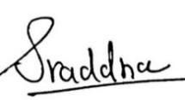

**Certificate**

I, **Ms. Vidhya Samad** certify that the project entitled **“Image Capture Application”** submitted in partial fulfillment for the award of the degree of Bachelor of Technology by **Ms. Sraddha Sharma** is the record carried out by her under my guidance and that the work has not formed the basis of award of any other degree elsewhere.

________________________________

Ms. Vidhya Samad

Information Technology

Medi-Caps University, Indore

________________________________

Mr. Deepak Katiyar

Technical Architect

Xoriant Solutions Pvt. Ltd

_____________________

Mrs Vaishali Chaurey

Head of the Department

Information Technology

Medi-Caps University, Indore

**Acknowledgements**

I would like to express my deepest gratitude to Honorable Chancellor, **Shri R C Mittal,** who has provided me with every facility to successfully carry out this project, and my profound indebtedness to **Prof. (Dr.) Sunil K Somani,** Vice Chancellor, Medi-Caps University, whose unfailing support and enthusiasm has always boosted up my morale. I also thank **Prof. (Dr.) D K Panda,** Dean, Faculty of Engineering, Medi-Caps University, for giving me a chance to work on this project. I would also like to thank my Head of the Department Information Technology for her continuous encouragement for betterment of the project.

I express my heartfelt gratitude to my **External Guide, Mr. Deepak Katiyar**, Technical Architect, Xoriant Solutions Pvt. Ltd as well as to my **Internal Guide, Ms. Vidhya Samad, Assistant Professor, Department of Information Technology, MU**, without whose continuous help and support, this project would ever have reached to the completion.

I would also like to thank to my team at Xoriant Solutions Pvt. Ltd who extended their kind support and help towards the completion of this project. It is their help and support, due to which we became able to complete the design and technical report.Without their support this report would not have been possible.

**Sraddha Sharma**

B.Tech. IV Year

Enrollment No: EN17IT301100

Department of Information Technology

Faculty of Engineering

Medi-Caps University, Indore

**Abstract**

The project is about Image Capture Application. It is a process of classifying optical patterns with respect to alphanumeric or other characters. This application includes the Optical character recognition process which does the segmentation, feature extraction and classification of the image or document file. This application converts Analog text-based resources to digital text resources. And then these converted resources can be used in several ways like searchable text in indexes to identify documents or images. As the first stage of text capture a digital copy of a page is taken, upload a scanned image from the computer, segmentation process in which we extract the text zone from the image, recognition of the text,post processing process in which the output of the previous stage goes through the error detection,get stored and displayed by converting text readable format. This report explains about the user interface with the help of which a user can very easily add or modify the segmentation done by the Image Capture Application

**Keywords:**

**Smart Capture, Document Image Analysis, Object Character Recognition, Data Simplified**

**Table of Contents**

|  |  |  |
| --- | --- | --- |
|  |  | **Page No.** |
|  |  |  |
|  | Report Approval | Ii |
|  | Declaration | Iii |
|  | Certificate | Iv |
|  | Acknowledgement | V |
|  | Abstract | Vi |
|  | Table of Contents | Vii |
|  | List of figures | Viii |
|  | List of tables | Ix |
|  | Abbreviations | X |
|  | Notations & Symbols | Xi |
| Chapter 1 | Introduction | 1-4 |
|  | 1.1 Introduction | 1 |
|  | 1.2 Objectives | 2 |
|  | 1.3 Future scope | 3 |
|  | 1.4 Significance | 4 |
| Chapter 2 | Implementation | 5-8 |
|  | 2.1 Experimental Set-up | 6-8 |
|  | 2.2 Procedures Adopted | 9 |
| Chapter 3 | System Analysis | 10-14 |
|  | 3.1 Information Flow Representation |  |
|  | 3.1.1 Data Flow Diagram | 11 |
|  | 3.1.2 Activity Diagram | 12 |
|  | 3.1.3 Use Case Diagram | 13 |
|  | 3.1.4 Flow Chart | 14 |
| Chapter 4 | Design | 15 |
|  | 4.1 Architectural Design | 16 |
|  | 4.2 Architectural Behavioral Diagram | 17 |
|  | 4.3 Procedural/Modular Approach | 18-26 |
| Chapter 5 | Testing | 27-33 |
|  | 5.1 Testing Objective | 28 |
|  | 5.2 Testing Scope | 28 |
|  | 5.3 Testing Principles | 29 |
|  | 5.4 Testing Methods Used | 29 |
|  | 5.5 Test Cases | 30 |
|  | 5.6 Sample Test Data & Results | 31-33 |
| Chapter 6 | Results and Discussions | 34-35 |
| Chapter 7 | Summary and Conclusions | 36-37 |
| Chapter 8 | Future scope | 38-40 |
| Chapter 9 | References | 41-42 |

**List of Tables**

|  |  |  |
| --- | --- | --- |
| **S.No** | **Table Name** | **Page NO.** |
| 1 | Test Cases |  |
| 1.1 | Login and Registration | 31 |
| 1.2 | Application | 31 |

**Abbreviations**

|  |  |  |
| --- | --- | --- |
| **S No.** | **Abbreviation** | **Full Form** |
| 1 | ICA | Image Capture Application |
| 2 | STS | Spring Tool Suite |
| 3 | API | Application Programming Interface |
| 4 | OCR | Object Character Recognition |

**Notations & Symbols**

ICA- Image Capture Application

 

 

**CHAPTER-1**

**INTRODUCTION**

**1) INTRODUCTION**

**1.1 INTRODUCTION**

Image Capture Application intuitively helps transform your paper-based business processes by leveraging best of breed OCR technology. Captures, classifies, and recognizes text. Image Capture Application is a Microsoft Azure based intuitive document digitization solution. It uses Microsoft Azure OCR services to extract printed/ handwritten text images (key-value pairs) from images and multi-page documents. This information can be stored in structured databases and analyzed using various tools for trending, dashboards, and reporting.Sometimes in this document processing we need to process the information. For this document processing we need a software system called IMAGE CAPTURE APPLICATION. This process is also called DOCUMENT IMAGE ANALYSIS (DIA). Thus, our need is to develop character recognition software system to perform Document Image Analysis which transforms documents in paper format to electronic format.

Widely used as a form of data entry from printed paper data records – whether passport documents, invoices, bank statements, computerized receipts, business cards, mail, printouts of static-data, or any suitable documentation. It is a common method of digitizing printed texts so that they can be electronically edited, searched, stored more compactly, displayed on-line, and used in machine processes such as cognitive computing, machine translation, (extracted) text-to-speech, key data and text mining. OCR is a field of research in pattern recognition, artificial intelligence and computer vision.

We start with the image of a document and the image is segmented corresponding to characters and symbols by the initial segmentation process. Then the initial hypotheses for each sub image are generated based on the features extracted from these sub images. These are composed into words which are varied and corrected if necessary.

**Features of Image Capture Application:**

1. Upload upto 1000 Pancard documents.
2. Reduced time and manual effort.
3. Data extraction and storage easy.
4. Good Accuracy and Fast.
5. Error minimized.

In Image Capture Application there will be two role one of Client and Admin.

**Client will be authenticated and given privileges for the application given below:**

1. Upload Pancard documents
2. Visualize data in tabular format.
3. View Batch Report
4. View Batch Process
5. View Pancard Details

Admin can grant the service according to the Client’s need, proper maintenance and monitoring will be done by the admin.

Image Capture Application intuitively helps transform your paper-based business processes by leveraging best of breed OCR technology. Captures, classifies, and recognizes text.

**1.2 OBJECTIVES**

Image Capture Application captures, classifies, recognizes text,store,displays data in a readable and accessible manner.

1. To reduce manual efforts
2. To visualize data in a simpler manner
3. To do fast documentation and data extraction
4. To automate the process of feeding the data extraction and storage.
5. To reduce the human error and improve accuracy.
6. To deploy the details to Client’s environment in the form of Batch Reports.

**1.3 SCOPE**

OCR engines have been developed into many kinds of domain-specific OCR applications, such as receipt OCR, invoice OCR, check OCR, legal billing document OCR.

1. **Font Independent OCR:**Development of OCR considering the multiple font style needs to be developed in the future. The corner point approach is very much useful for the font independent OCR, because, for font or character size, it finds the block and the blocks are analyzed to recognize the character.
2. **OCR for all Indian Languages:**Development of OCR for languages other than English needs to be researched on and developed in the future. The corner point approach is very much useful for the OCR of languages other than English, because, for font or character size, it finds the block and the blocks are analyzed to recognize the character.
3. **Cursive Characters OCR:**There is heavy demand for an OCR system which recognizes handwritten cursive scripts. This avoids keyboard typing and font coding for the image. This method helps in detecting handwritten characters with a precision of about 90%.
4. **Speech recognition from OCR:** Speech recognition is one of the most important application today. The recognized Printed or Handwritten OCR could be recorded, and speech output could be generated. This would help the blind to send and receive information.
5. **Speech to text converter through OCR:**Speech recognition is one of the most important application today. The recognized speech could be recorded, and output of text could be generated.
6. **Applications:**They can be used for:

* Data entry for business documents, e.g., Cheque, passport, invoice, bank statement and receipt
* Automatic number plate recognition
* In airports, for passport recognition and information extraction
* Automatic insurance documents key information extraction
* Traffic sign recognition.
* Extracting business card information into a contact list.
* More quickly make textual versions of printed documents.

**1.4 SIGNIFICANCE**

1. **Searchability:**OCR engine processed data are transferred in searchable text formats, such as Doc, RTF, txt, pdf, etc. Moreover, the required information can be internally found using a computer command Ctrl+F/Command+F.
2. **Editability:**Once a paper document is digitized with an character recognition app, it can be easily amended with a word processor.
3. **Storability:**Digital text data, both current and historical, are automatically stored  in electronic libraries and storages.
4. **Accessibility:**Digital storages of electronic documents can be easily accessed by locally distributed users.
5. **Translatability:**OCR-powered solutions also embrace translational capabilities. An OCR engine is used for extracting the text from a scanned document and then translating it to a different language.
6. **Backups:**Digital back-ups are cost-effective, and potentially, can be done an infinite number of times. Instead of maintaining costly duplicates and triplicates in paper form, object recognition software automatically creates **OCR backups.**

**CHAPTER-2**

**IMPLEMENTATION**

**2.1 Experimental Set-up**

**2.1.1 Platform specification**

* **Software**

1. **Visual Studio Code**

Visual Studio Code is afreeware [source-code editor](https://en.wikipedia.org/wiki/Source-code_editor) made by [Microsoft](https://en.wikipedia.org/wiki/Microsoft) for [Windows](https://en.wikipedia.org/wiki/Windows), [Linux](https://en.wikipedia.org/wiki/Linux) and [macOS](https://en.wikipedia.org/wiki/MacOS). Features include support for [debugging](https://en.wikipedia.org/wiki/Debugging), [syntax highlighting](https://en.wikipedia.org/wiki/Syntax_highlighting), [intelligent code completion](https://en.wikipedia.org/wiki/Intelligent_code_completion), [snippets](https://en.wikipedia.org/wiki/Snippet_(programming)), [code refactoring](https://en.wikipedia.org/wiki/Code_refactoring), and embedded [Git](https://en.wikipedia.org/wiki/Git). Users can change the [theme](https://en.wikipedia.org/wiki/Theme_(computing)), [keyboard shortcuts](https://en.wikipedia.org/wiki/Keyboard_shortcut), preferences, and install [extensions](https://en.wikipedia.org/wiki/Plug-in_(computing)) that add additional functionality.

Microsoft has released Visual Studio Code's [source code](https://en.wikipedia.org/wiki/Source_code) on the Microsoft/Vscode (Code - OSS) repository of [GitHub](https://en.wikipedia.org/wiki/GitHub), under the permissive [MIT License](https://en.wikipedia.org/wiki/MIT_License), while the releases by Microsoft are [freeware](https://en.wikipedia.org/wiki/Freeware) but not released under an open-source license



1. **Spring Tool Suite**

Spring Tools 4 is the next generation of Spring tooling for your favorite coding environment. Largely rebuilt from scratch, it provides world-class support for developing Spring-based enterprise applications, whether you prefer Eclipse, Visual Studio Code, or Theia IDE**.** Spring Tool Suite is an IDE to develop Spring applications. It is an Eclipse-based development environment. It provides a ready-to-use environment to implement, run, deploy, and debug the application. It validates our application and provides quick fixes for the applications.



1. **Postman**

Postman is one of the most popular software testing tools which is used for API testing. With the help of this tool, developers can easily create, test, share, and document APIs.

* Postman is a standalone software testing API (Application Programming Interface) platform to build, test, design, modify, and document APIs. It is a simple Graphic User Interface for sending and viewing HTTP requests and responses.
* While using Postman, for testing purposes, one doesn't need to write any HTTP client network code. Instead, we build test suites called collections and let Postman interact with the API.
* In this tool, nearly any functionality that any developer may need is embedded. This tool has the ability to make various types of HTTP requests like GET, POST, PUT, PATCH, and convert the API to code for languages like JavaScript and Python.



1. **XAMPP**

XAMPP is an abbreviation where X stands for Cross-Platform, A stands for Apache, M stands for [MYSQL](https://www.javatpoint.com/mysql-tutorial), and the Ps stand for PHP and Perl, respectively. It is an open-source package of web solutions that includes Apache distribution for many servers and command-line executables along with modules such as Apache server, [MariaDB](https://www.javatpoint.com/mariadb-tutorial), PHP, and Perl.

XAMPP helps a local host or server to test its website and clients via computers and laptops before releasing it to the main server. It is a platform that furnishes a suitable environment to test and verify the working of projects based on Apache, Perl, MySQL database, and PHP through the system of the host itself. Among these technologies, [Perl](https://www.javatpoint.com/perl-tutorial) is a programming language used for web development, [PHP](https://www.javatpoint.com/php-tutorial) is a backend scripting language, and MariaDB is the most vividly used database developed by MySQL.



1. **OS - Windows 10**

Windows 10 is a series of operating systems developed by Microsoft and released as part of its Windows NT family of operating systems. It is the successor to Windows 8.1, released nearly two years earlier, and was released to manufacturing on July 15, 2015, and broadly released for 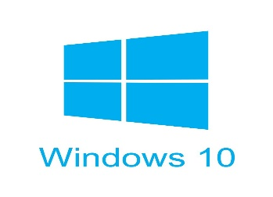the public on July 29, 2015.

* **Services**

1. **Microsoft Azure OCR**

The cloud-based Computer Vision API provides developers with access to advanced algorithms for processing images and returning information. By uploading an image or specifying an image URL, Microsoft Computer Vision algorithms can analyze visual content in different ways based on inputs and user choices.

* **Cloud Storage**

1. **MongoDB Atlas**

The most innovative cloud database service on the market, with unmatched data distribution and mobility across AWS, Azure, and Google Cloud, built-in automation for resource and workload optimization, and so much more. MongoDB Atlas is a fully-managed cloud database developed by the same people that build MongoDB. Atlas handles all the complexity of deploying, managing, and healing your deployments on the cloud service provider of your choice (AWS, Azure, and GCP).’



* 1. **Procedures Adopted**

**Deployment steps of Project:**

1. **First we need to install Spring Tool Suite, Visual Studio Code, Postman,MongoDB (Compass/Atlas) and XAMPP software in your PC/Laptop.**
2. **Start the XAMPP Tomcat Server, goto the file where you have Pancard documents, hit the API in Visual Studio Code to fetch all the documents, verify through Postman and goto Spring Tool Suite and run the Image Capture Application.**
3. **All the files that you have fetched will be downloaded in the directed folder and then the data will get extracted.**
4. **Extracted data will get stored in the MongoDB database in the form of collections.**
5. **Then, we created a GUI for presenting our implementation which contains the Pancard Details, Batch Processes and Batch Reports.**
6. **After getting logged in the three services will be visible and you can view them.**

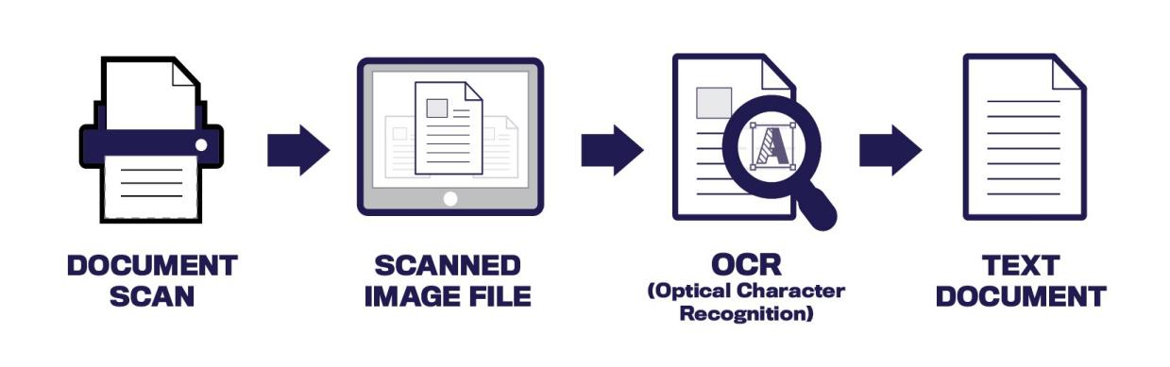

**CHAPTER 3**

**SYSTEM ANALYSIS**

1. **System Analysis**

**3.1 Information flow Representation**

**3.1.1 Data Flow Diagram**

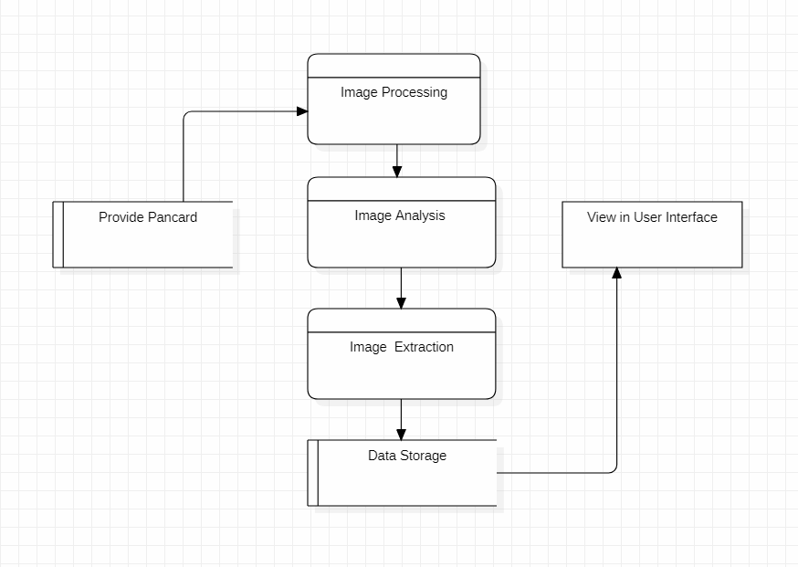

**3.1.2 Activity Diagram**

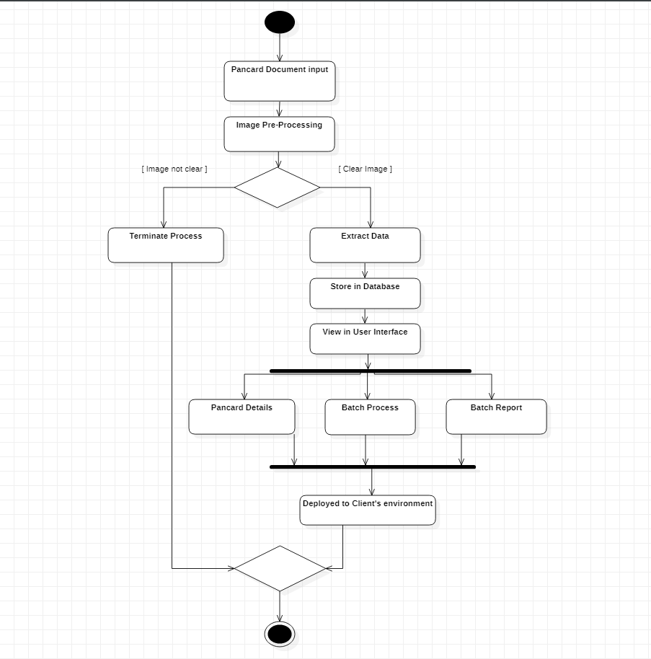

**3.1.3 Use Case Diagram**

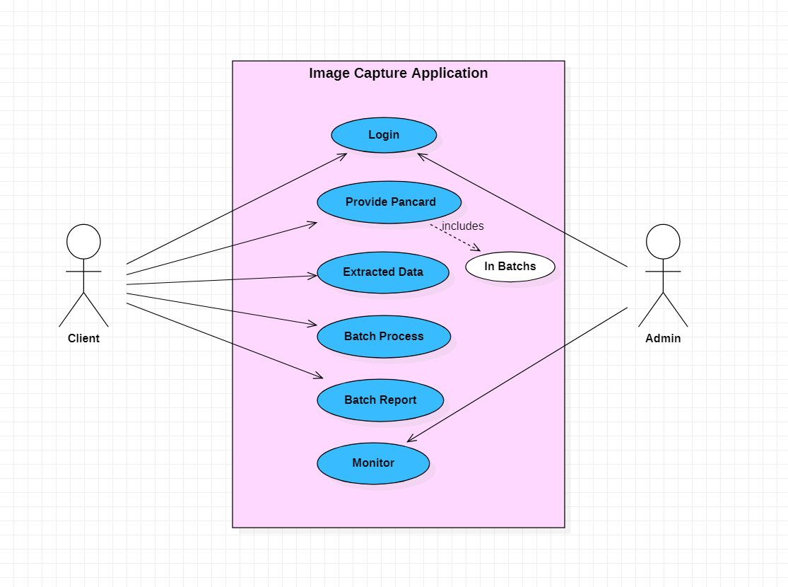

**3.1.3 Flow Chart**

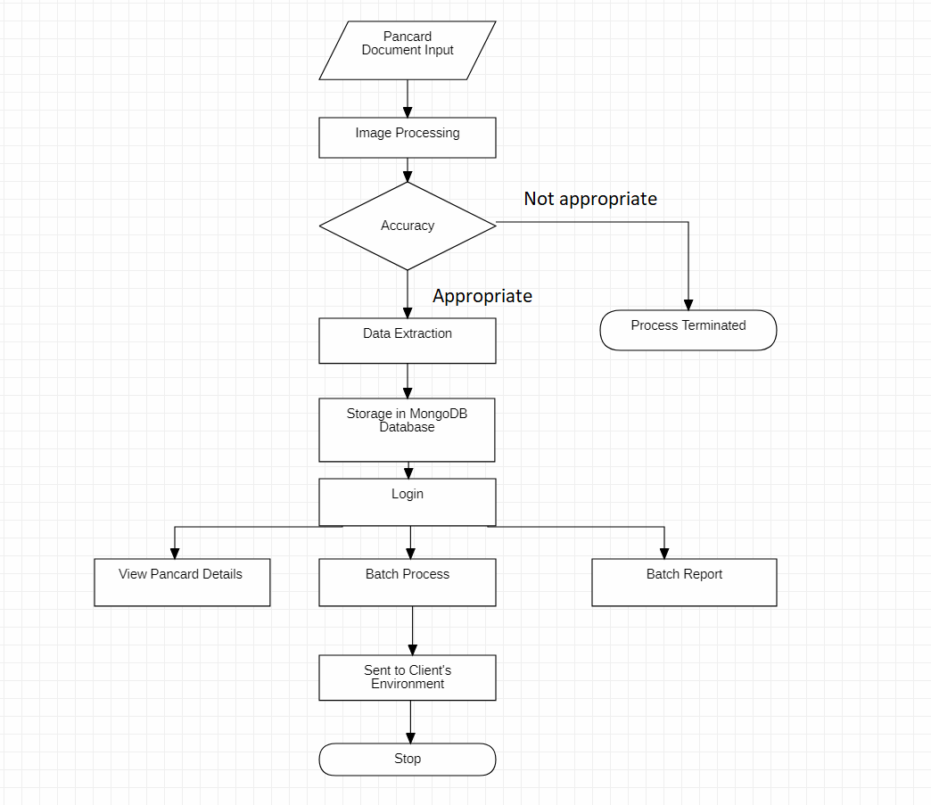

**CHAPTER 4**

**DESIGN**

**4.1) Architectural Design**

The software needs the architectural design to represent the design of software. IEEE defines architectural design as “the process of defining a collection of hardware and software components and their interfaces to establish the framework for the development of a computer system.” The software that is built for computer-based systems can exhibit one of these many architectural styles.

Each style will describe a system category that consists of:

• A set of components (e.g.: a database, computational modules) that will perform a function required by the system.

• The set of connectors will help in coordination, communication, and cooperation

between the components.

• Conditions that how components can be integrated to form the system.

• Semantic models that help the designer to understand the overall properties of the system.

The use of architectural styles is to establish a structure for all the components of the system.

**4.1.2 Architectural Behavioural Diagram**

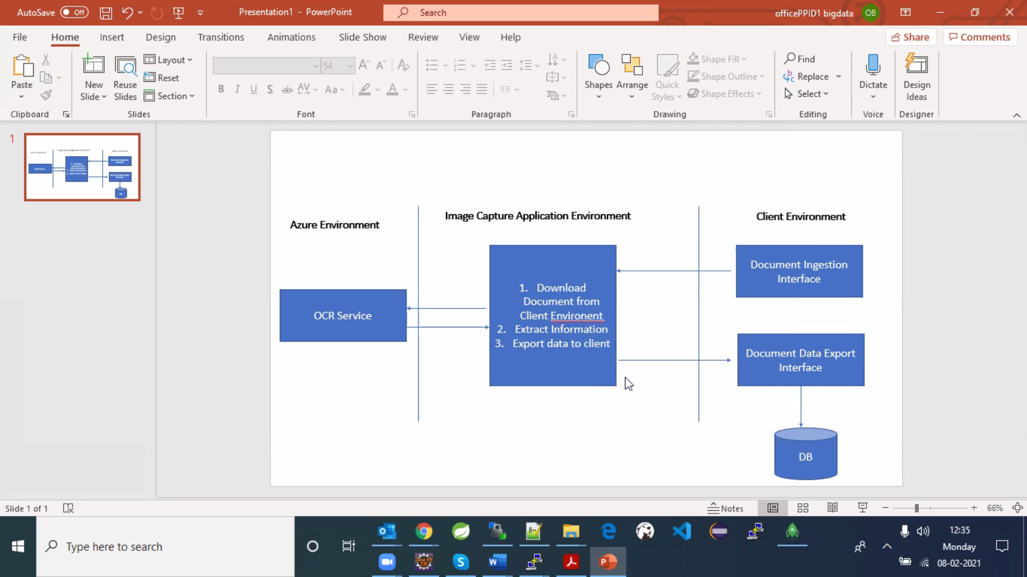

Fig 4.1 Architectural Behavioural Diagram

**4.3 Modular Approach**

Modular Approach in Programming Modular programming is the process of subdividing a computer program into separate subprograms. A module is a separate software component. It can often be used in a variety of applications and functions with other components of the system.

• Some programs might have thousands or millions of lines and to manage such programs it becomes quite difficult as there might be too many of syntax errors or logical errors present in the program, so to manage such type of programs concept of modular programming approached.

• Each sub-module contains something necessary to execute only one aspect of the desired functionality.

• Modular programming emphasis on breaking of large programs into small problems to increase the maintainability, readability of the code and to make the program handy to make any changes in future or to correct the errors.

**4.3.1 Modules Used**

1. **Module 1: Local Storage**

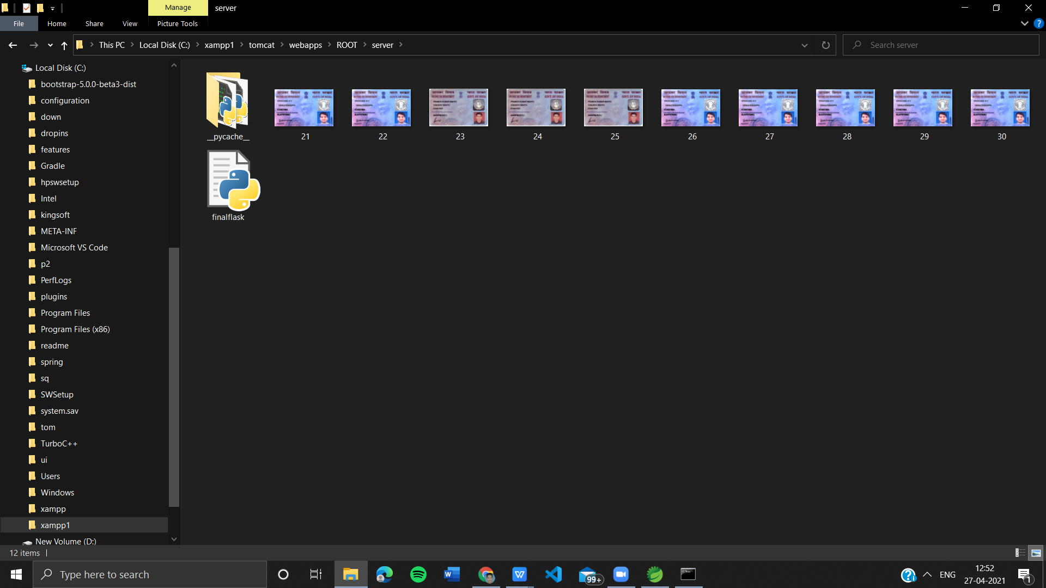

1. **Module 2: Application**

* **Fetch files from Local Storage**

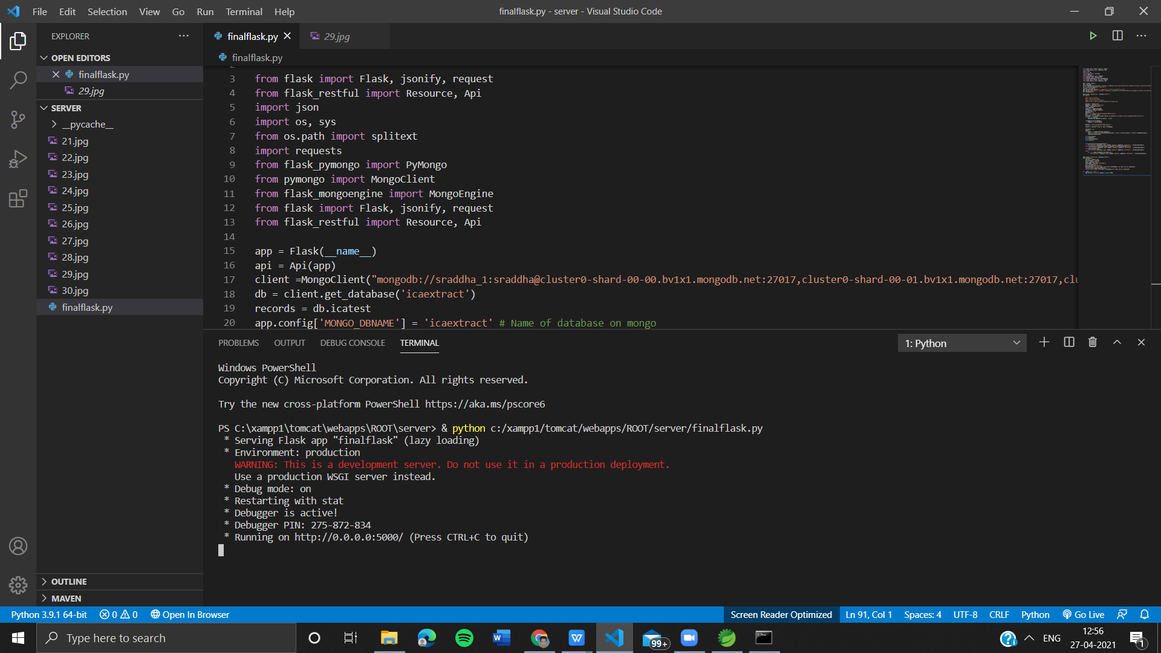

* **Verify the extraction of files from Storage**

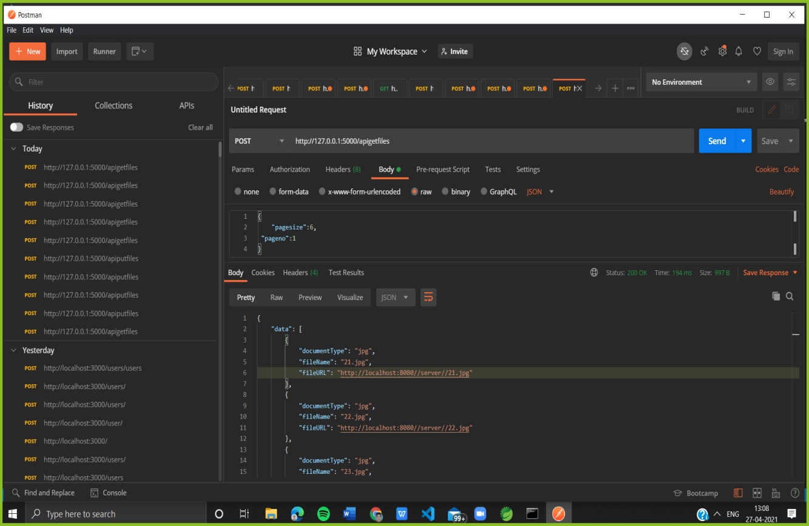

* **Local Server Application**

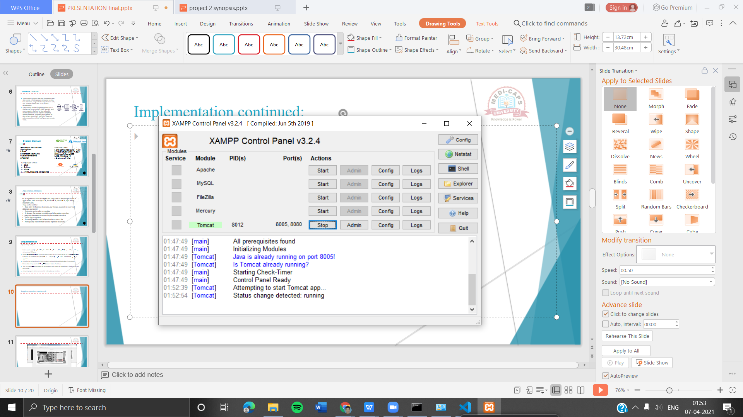

* **Application**

1. The extracted files gets download and stored
2. The OCR is performed and data is extracted
3. The extracted details gets stored in MongoDB atlas

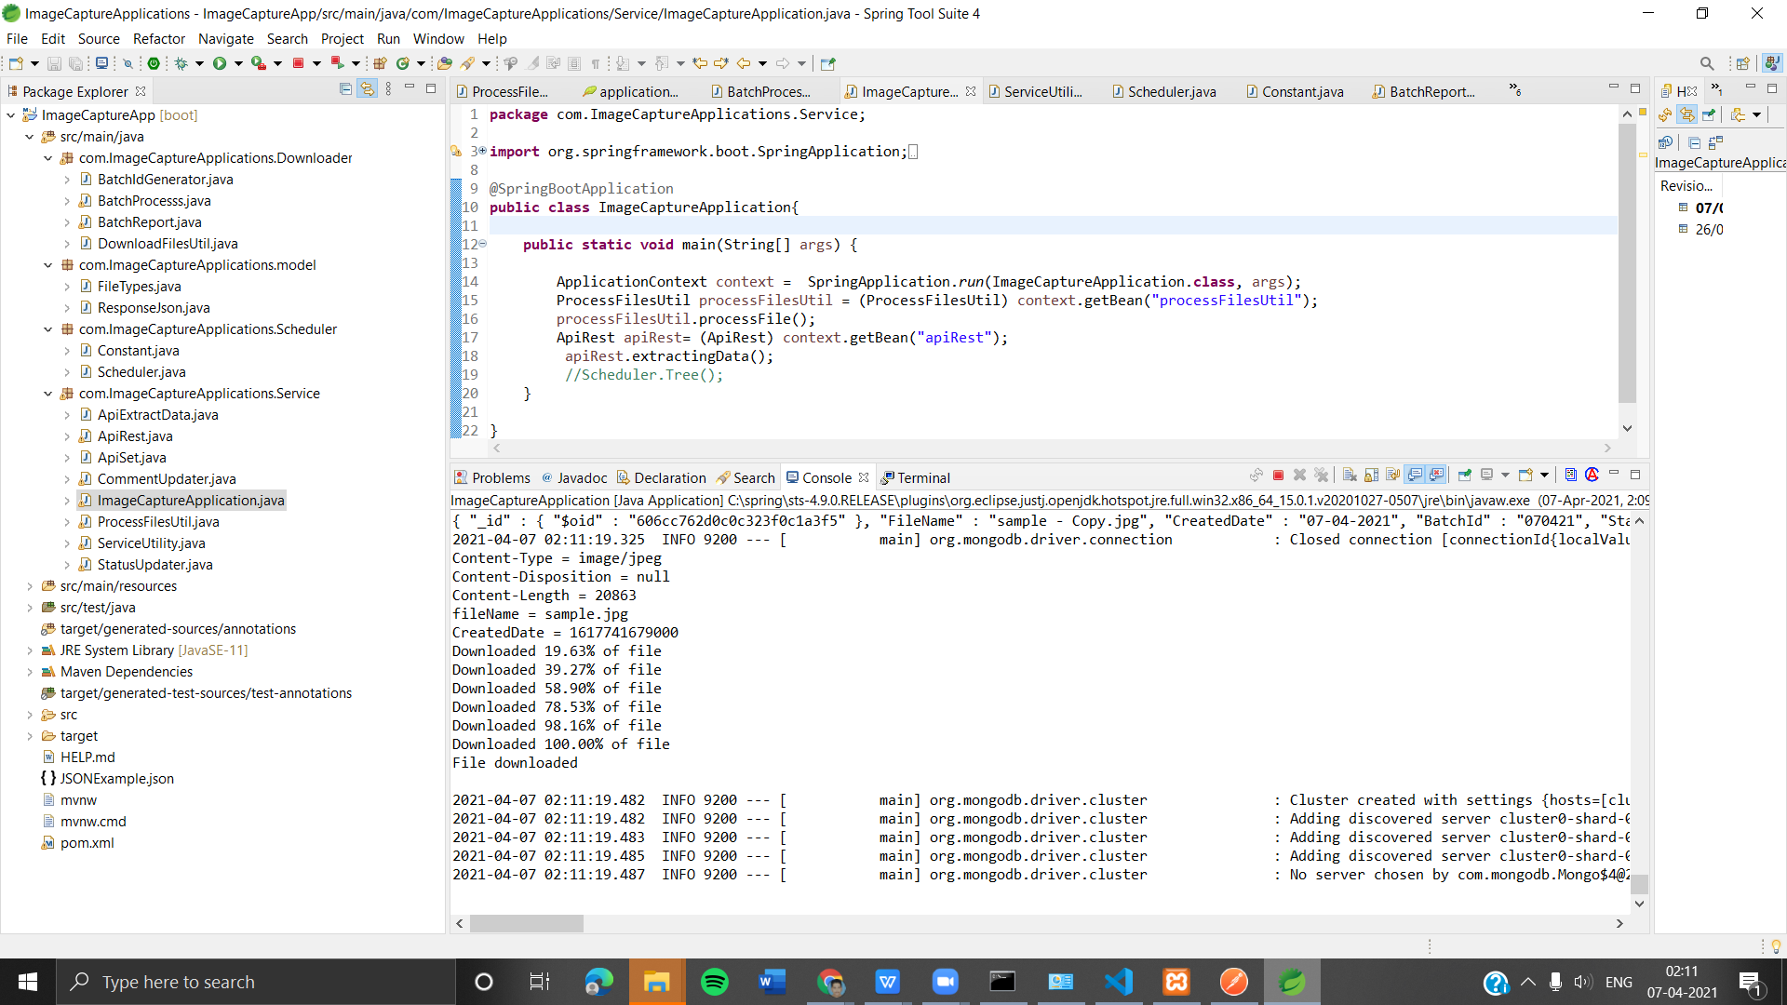

1. **Module 3: Cloud Storage**

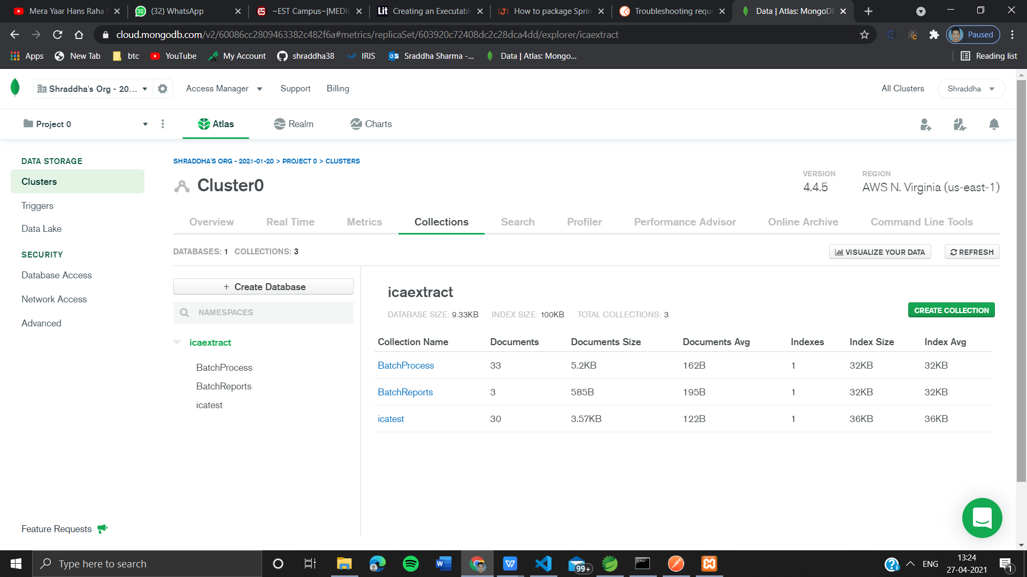

1. **Module 4: Front End**

* **Register and Login**

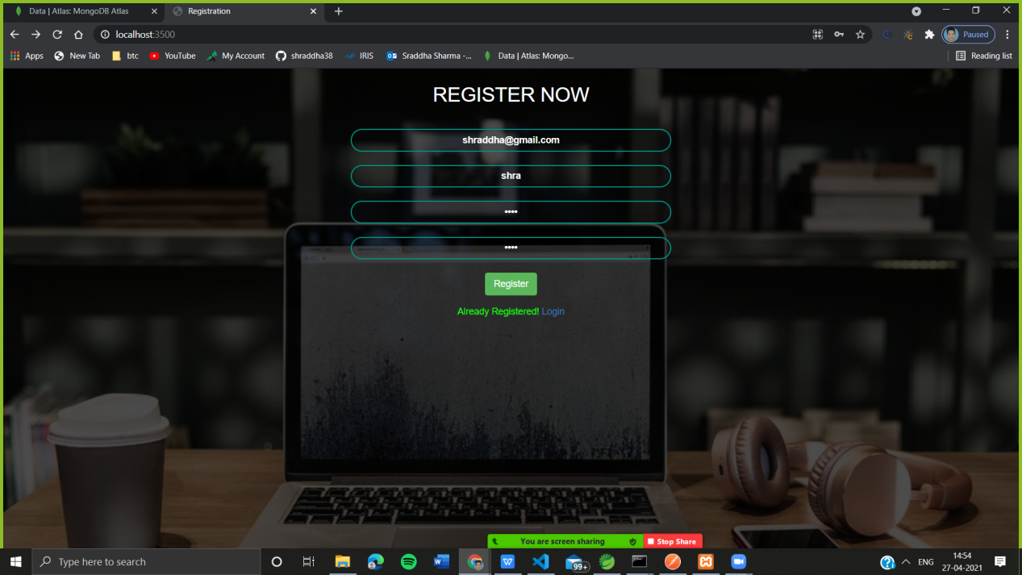

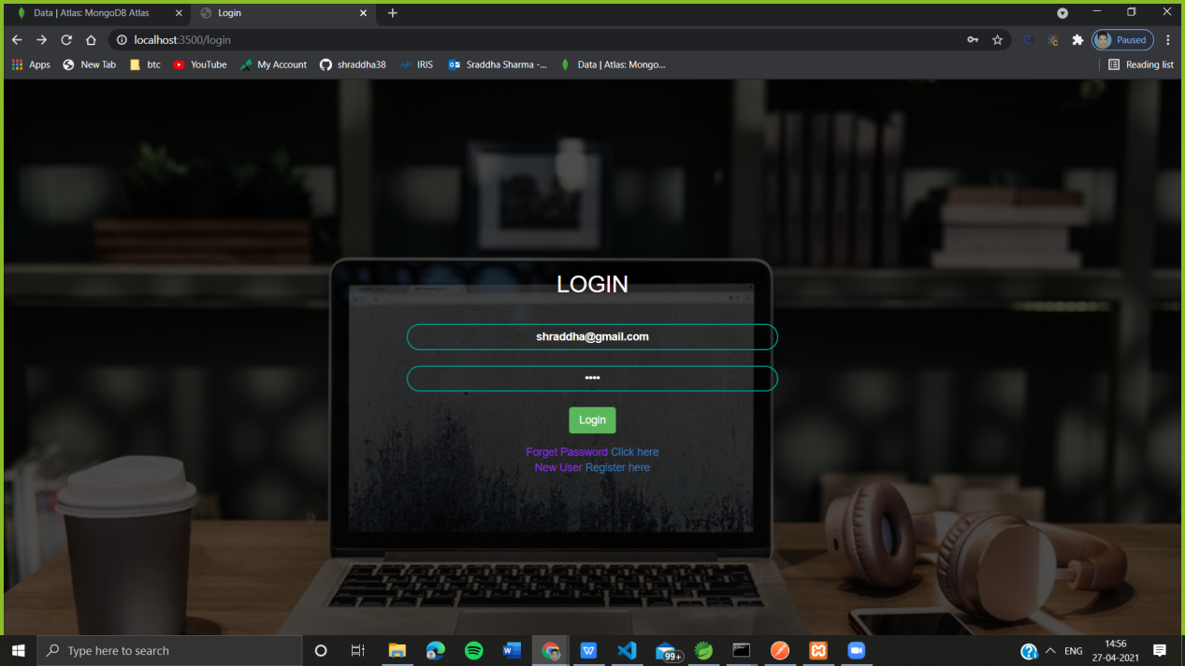

* **Home Page**

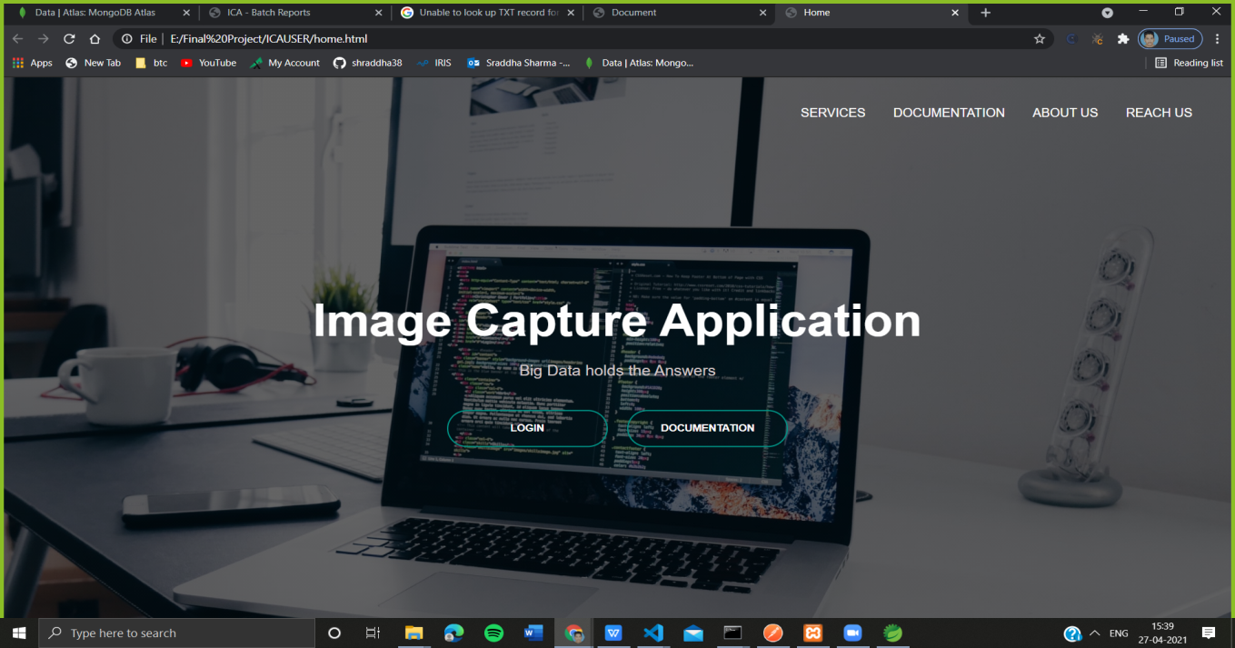

* **Service Page**

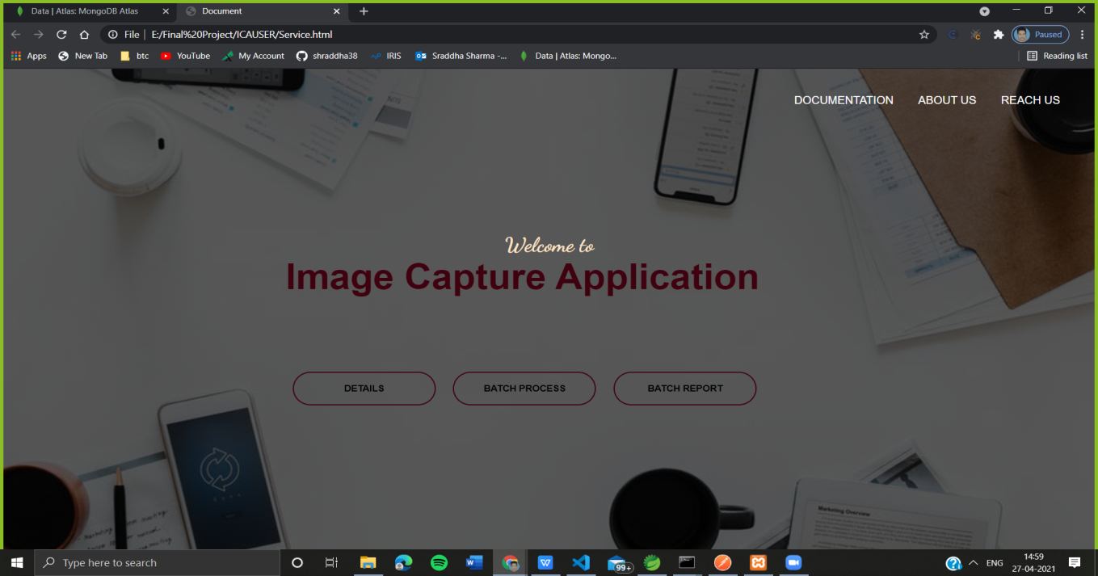

* **Batch Report of Processes**

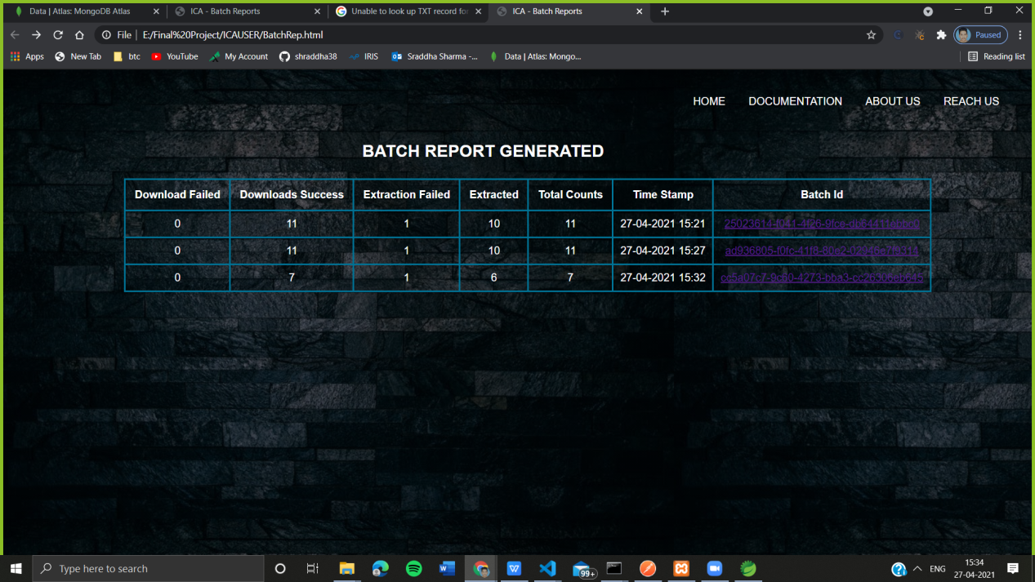

* **Batch Processes Page**

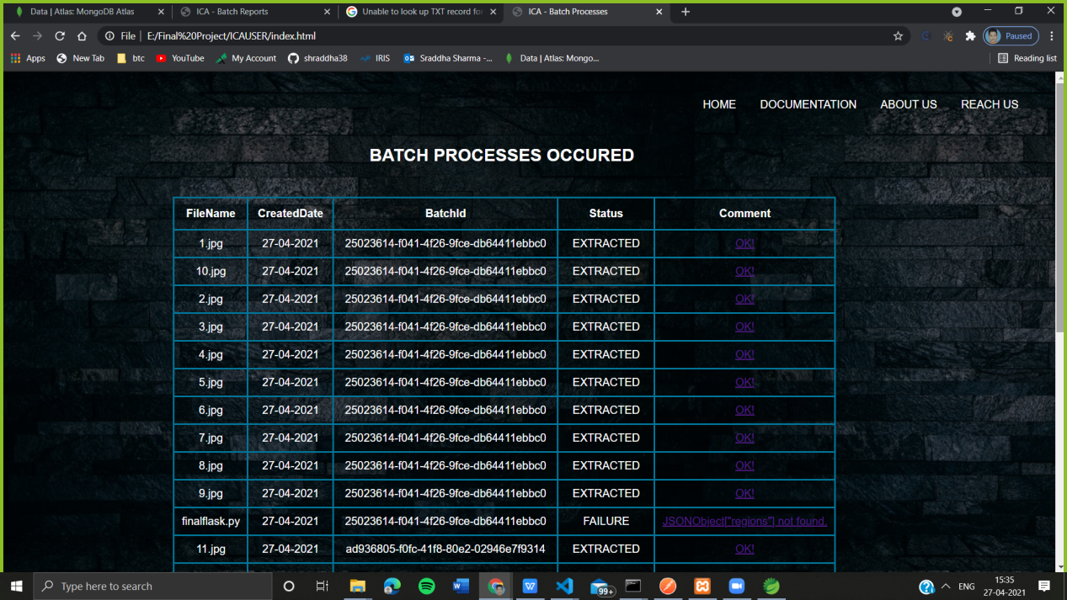

* **Pancard Details**

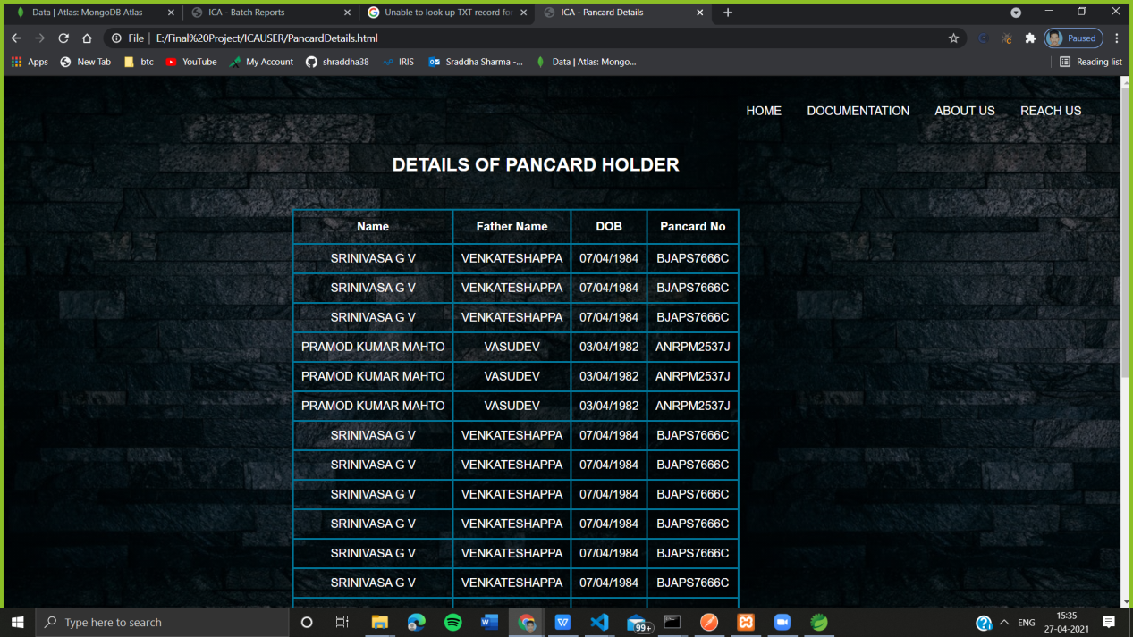

* **About Us Page**

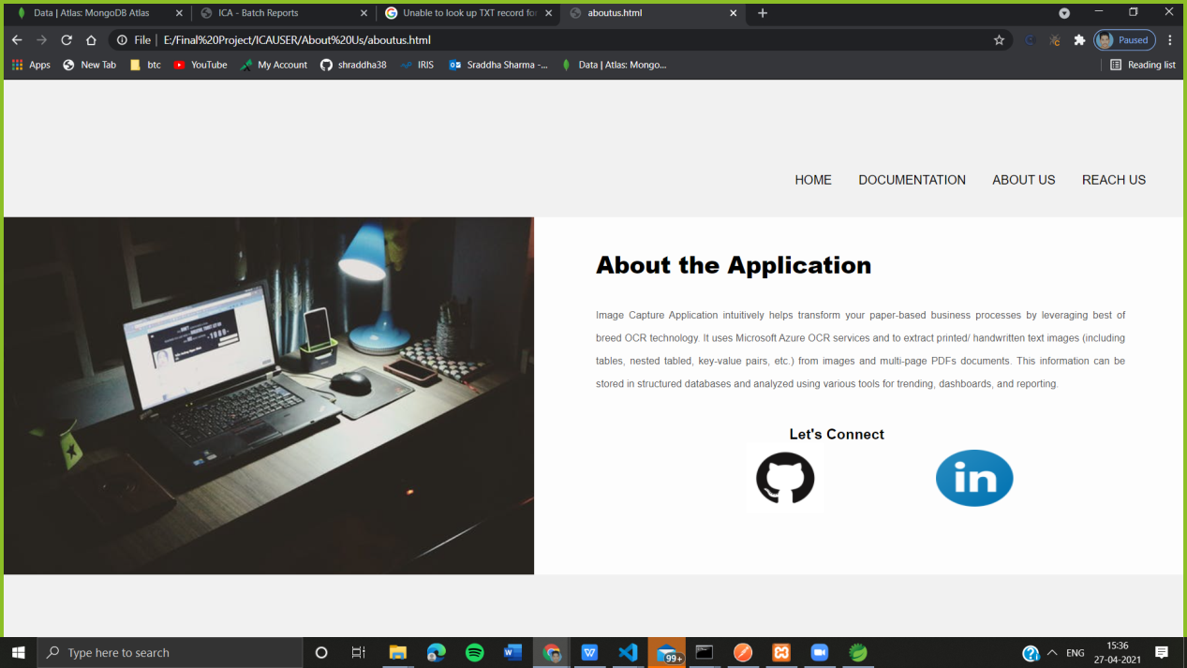

**CHAPTER 5**

**TESTING**

**5.Testing**

Software testing is a process of executing a program with the aim of finding the error. To make our software perform well it should be error free. If testing is done successfully, it will remove all the errors from the software.

**5.1 Testing Objectives**

Software testing has different goals and objectives.

The major Objectives of Software testing are as follows:

* Finding defects which may get created by the programmer while developing the software.
* Gaining confidence in and providing information about the level of quality.
* To prevent defects.
* To make sure that the result meets the business and user requirements.
* To ensure that it satisfies the BRS that is Business Requirement Specification and SRS that is System Requirement Specifications.
* To gain the confidence of the customers by providing them a quality

product.

**5.2 Testing Scope**

The following things should be taken for testing:

1. The username should be unique to avoid duplicate users.
2. The username and password entered should match the registered user.
3. There should be some files in the local storage before application runs.
4. The file type must be JPEG/PNG for data extraction and storage.
5. The image should be clear and readable.

**5.3 Testing Principles:**

Software testing is a process of executing a program with the aim of finding the error. To make our software perform well it should be error free. If testing is done successfully, it will remove all the errors from the software.

**There are seven principles in software testing:**

1. Testing shows presence of defects.
2. Exhaustive testing is not possible.
3. Early testing
4. Defect clustering
5. Pesticide paradox
6. Testing is context dependent.
7. Absence of errors fallacy

* **Testing shows presence of defects:** The goal of software testing is to make the software fail. Software testing reduces the presence of defects. Software testing talks about the presence of defects and does not talk about the absence of defects. Software testing can ensure that defects are present, but it cannot prove that software is defects free. Even multiple testing can never ensure that software is 100% bug-free. Testing can reduce the number of defects but not removes all defects.
* **Exhaustive testing is not possible:** The process of testing the functionality of a software in all possible inputs (valid or invalid) and pre-conditions is known as exhaustive testing. Exhaustive testing is impossible. This means the software can never test at every test cases. It can test only some test cases and assume that software is correct, and it will produce the correct output in every test cases. If the software will test every test case, then it will take more cost, effort, etc. and which is impractical.
* **Early Testing:** To find the defect in the software, early test activity shall be started. The defect detected in early phases of SDLC will be less expensive. For better performance of software, software testing will start at initial phase i.e. testing will perform at the requirement analysis phase.
* **Defect clustering:** In a project, a small number of the module can contain most of the defects. Pareto Principle to software testing state that 80% of software defect comes from 20% of modules.
* **Pesticide paradox:** Repeating the same test cases again and again will not find new bugs. So, it is necessary to review the test cases and add or update test cases to find new bugs.
* **Testing is context dependent:** Testing approach depends on context of software developed. Different types of software need to perform different types of testing. For example, the testing of an e-commerce website is different from the testing of an Android application.
* **Absence of errors fallacy:** If a built software is 99% bug-free but it does not follow the user requirement then it is unusable. It is not only necessary that software is 99% bug-free but it is also mandatory to fulfil all the customer requirements.

**5.4 Testing Method Used**

Testing methodologies are approaches to testing, from unit testing through system testing and beyond. There is no formally recognized body of testing methodologies, and very rarely will you ever find a unified set of definitions. But here are some common methodologies:

* **Unit Testing:** The act of testing software at the most basic (object) level. Generally performed by developers, run in "friend classes" with code-level access to read and manipulate objects.
* **Acceptance Testing:** Also known as acceptance tests, build verification tests, basic verification tests, these are rudimentary tests which prove whether a given build is worth deeper testing. The term "smoke test" is a colloquial term -- when machines are built, engineers will power them up and just let them run, looking for smoke as a sign of serious problems.
* **Functional testing-**Functional testing takes a user story or a product feature and tests all of the functionality contained within that feature. For example, in a photo application like Photoshop, functional testing would cover all the functionality contained within a feature like opening files (resolving file paths, determining appropriate format filters, passing the file path off to the filter) as well as handling errors within that functionality.
* **System Testing-**Testing the project as a collective system. For the Photoshop application, an example would be to open a file in a given format, manipulate that file in various ways, and then output the file. System testing generally combines multiple features into an end- to-end process or scenario.
* **Performance Testing-**Tests an application's performance characteristics, be it file size, concurrent users, or mean-time-to-failure.
* **Security Testing-**A collection of tests focused on probing an application's security, or its ability to protect user assets.
* **Black Box Testing-** Black box testing treats the software as a “black box” i.e., without any knowledge of internal implementation. Black box testing methods includes:
  1. Equivalence Partitioning.
  2. Boundary Value analysis.
  3. All pair testing.
  4. Model- Based testing.
  5. Exploratory testing.
  6. Specification Based testing.
* **White Box Testing -** White box testing is when the tester has access to the internal data structures and algorithms including the code that implement these. White-box testing can be applied at the unit, integration and system levels of the software testing process.

### 5.5 Test Cases

1. **Case 1: Login and Registration**

|  |  |  |  |
| --- | --- | --- | --- |
| **S. No** | **Input Description** | **Expected Output** | **Pass/Fail** |
| 1 | If username entered is valid | Successful | Pass |
| 2 | If password entered is valid | Successful | Pass |
| 3 | If Email entered is already in use | Error | Pass |

1. **Case 2: Application**

|  |  |  |  |
| --- | --- | --- | --- |
| **S. No** | **Input Description** | **Expected Output** | **Pass/Fail** |
| 1 | If No file is present in the Local Storage | No File Found | Pass |
| 2 | If there are 20 files or less | Extracted and Stored | Pass |
| 3 | If the file other than type of JPEG/PNG | Extraction Failed | Pass |
| 4 | If the image is Blurred | Extracted and Stored | Fail |

**5.6 Sample Test Data & Results**

* **If the file other than type of JPEG/PNG**

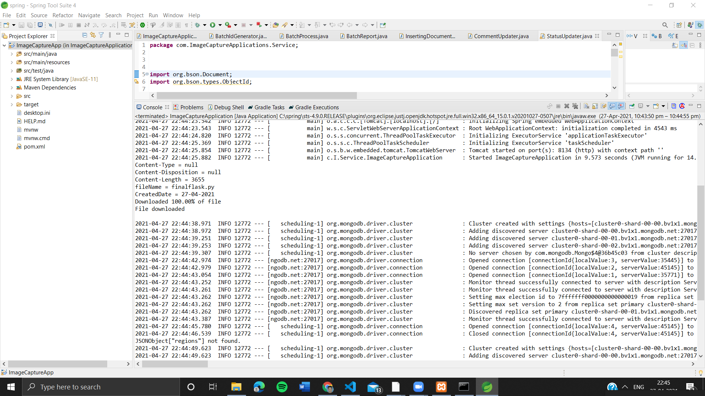

* **If the image is Blurred**

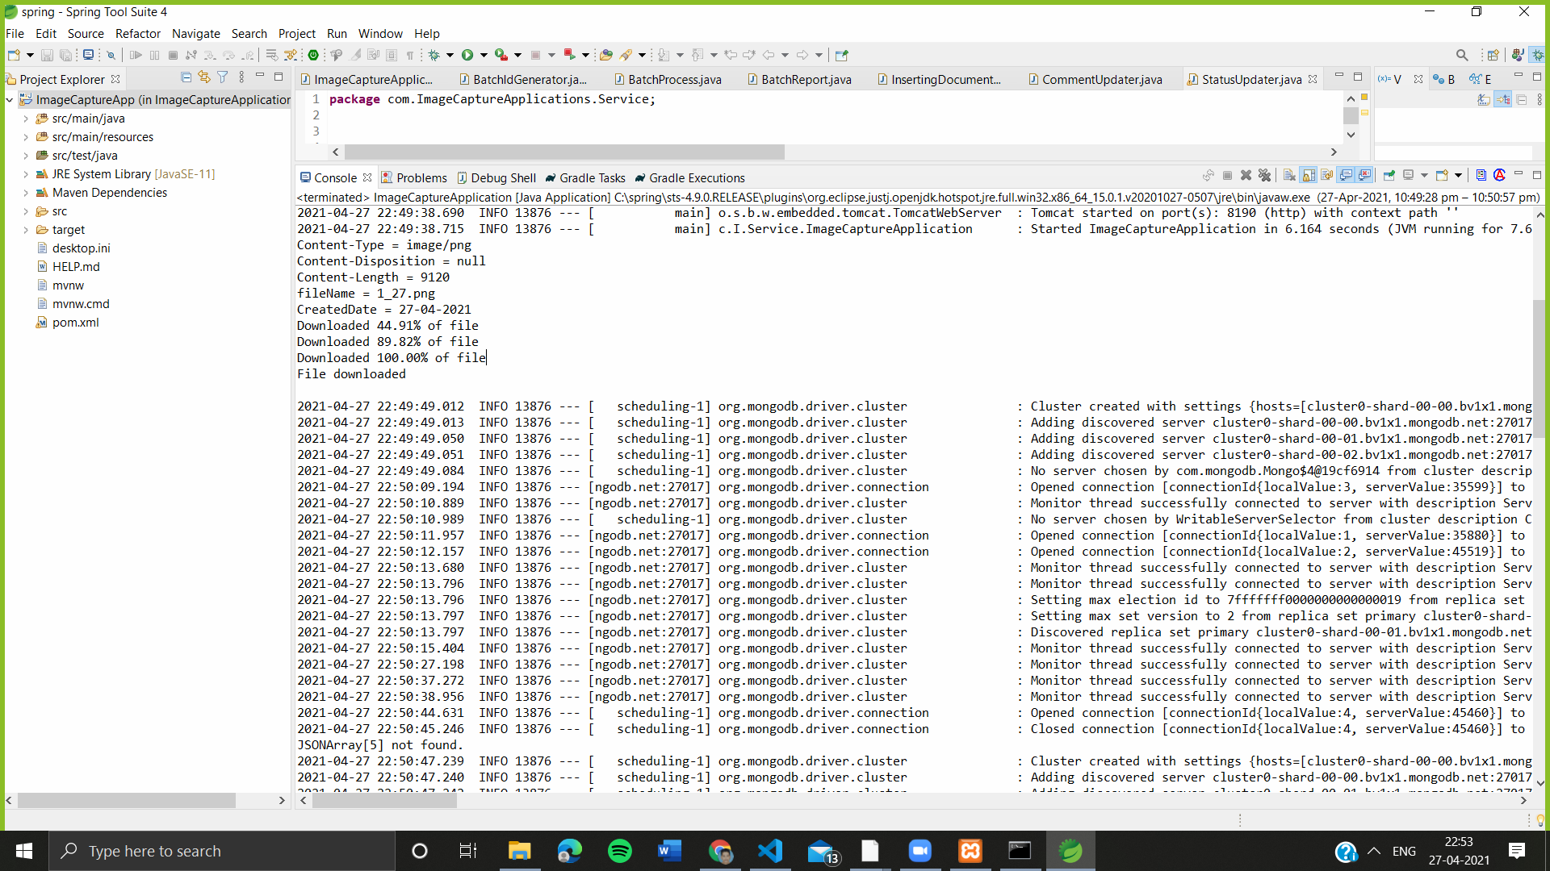

* **If No file is present in the Local Storage**

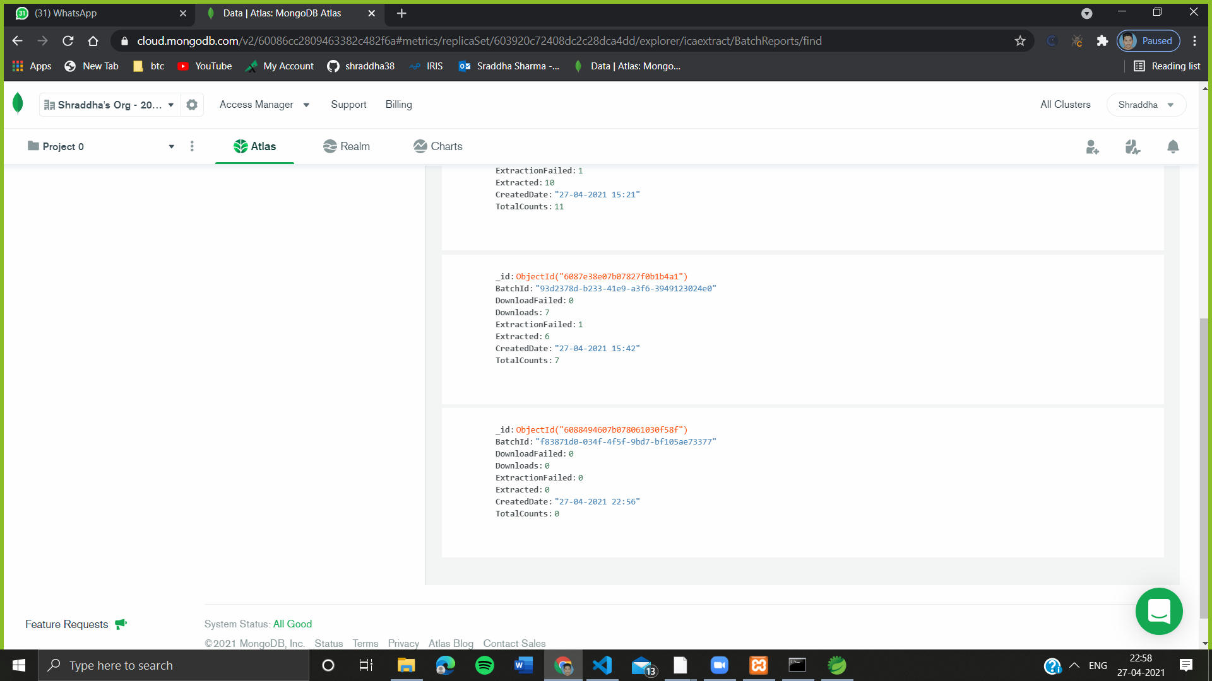

* **Email not registered**

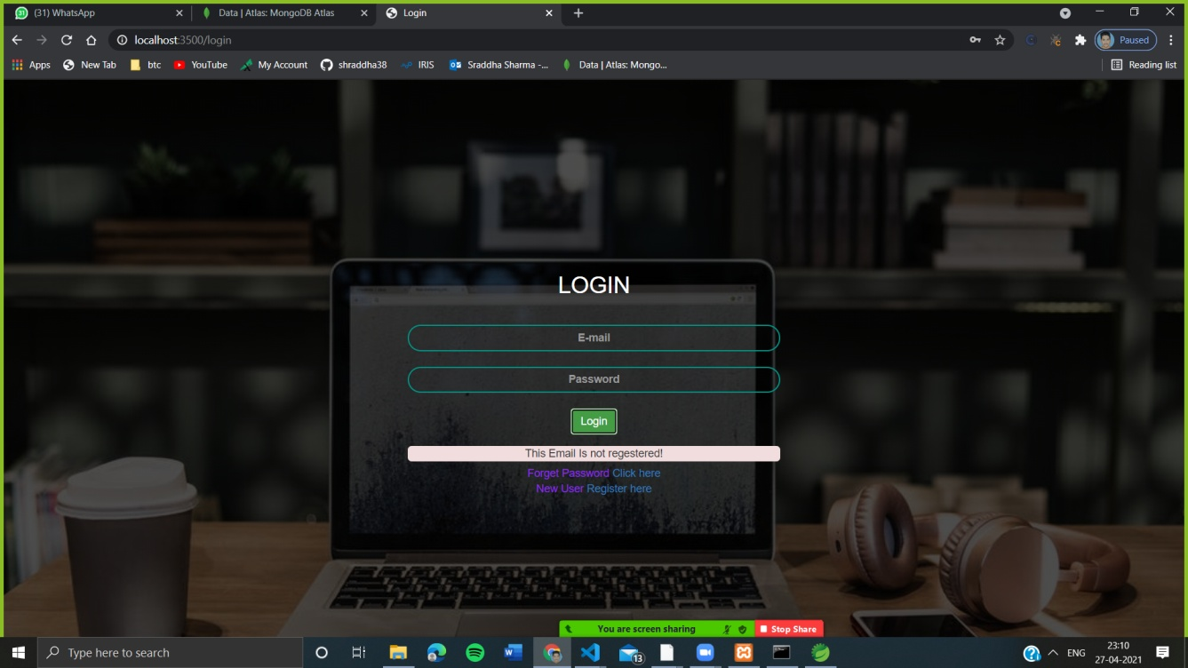

**CHAPTER 6**

**Results and Discussions**

* 1. **Results & Discussion**

After the project completion we drew the following results Image Capture Application captures, classifies, recognizes text,store,displays data in a readable and accessible manner.

* To reduce manual efforts
* To visualize data in a simpler manner
* To do fast documentation and data extraction
* To automate the process of feeding the data extraction and storage.
* To reduce the human error and improve accuracy.
* To deploy the details to Client’s environment in the form of Batch Reports.

Here I learned various new things which includes blob storage ,OCR, Node,Postman,Spring,Flask etc Proved helpful and enhanced my profile as well.

**CHAPTER 7**

**Summary and Conclusions**

### 7.1Summary

Image Capture Application intuitively helps transform your paper-based business processes by leveraging best of breed OCR technology. This application Captures, classifies, and recognizes texts and helps in the digitization of the documentations. This application includes the Optical character recognition process which does the segmentation, feature extraction and classification of the image or document file. With more and more advancement in this, this application can be built as a scalable model and can easily be deployed in industries and sectors requiring data to be stored digitally for e.g. Banking, Health Sector, Financial Industry, Schools and Colleges etc. This application is a robust model and can be trained for various kind of document templates and forms in future as per the client demand and requirements.

### 7.2 Conclusion

What does the future hold for Image Capture Application? Given enough entrepreneurial designers and sufficient research and development dollars, ICA can become a powerful tool for future data entry process. However, the limited availability of funds in a capital-short environment could restrict the growth of this application. But, given the proper impetus and encouragement, a lot of benefits can be provided by this ICA.

They are:

1. The automated entry of data by ICA is one of the most attractive, labor reducing technology ➢ The recognition of new font characters by the application is very easy and quick.
2. We can edit the information of the documents more conveniently and we can reuse the edited information as and when required. ➢
3. The extension to software other than editing and searching is topic for future works.
4. A wide range of documents can be processed through this ICA.
5. The extracted and stored data can be more efficiently used for further analysis if needed.
6. Minimal error rate can be expected as the human intervention has been reduced.

The Azure Services used in the ICA along with some scheduling algorithms can be efficiently used to speed up the translation of Image based documents into structured documents that are currently easy to discover, search and process.

**CHAPTER 8**

**Future scope**

**8.1 Font Independent OCR:**

Development of OCR considering the multiple font style needs to be developed in the future. The corner point approach is very much useful for the font independent OCR, because, for font or character size, it finds the block and the blocks are analyzed to recognize the character.

**8.2 OCR for all Indian Languages:**

Development of OCR for languages other than English needs to be researched on and developed in the future. The corner point approach is very much useful for the OCR of languages other than English, because, for font or character size, it finds the block and the blocks are analyzed to recognize the character.

**8.3 Cursive Characters OCR:**

There is heavy demand for an OCR system which recognizes handwritten cursive scripts. This avoids keyboard typing and font coding for the image. This method helps in detecting handwritten characters with a precision of about 90%.

**8.4 Speech recognition from OCR:**

Speech recognition is one of the most important application today. The recognized Printed or Handwritten OCR could be recorded and speech output could be generated. This would help the blind to send and receive information.

**8.5 Speech to text converter through OCR:**

Speech recognition is one of the most important application today. The recognized speech could be recorded and output of text could be generated.

**8.6 Applications:**

They can be used for:

• Data entry for business documents, e.g. Cheque, passport, invoice, bank statement and receipt

• Automatic number plate recognition

• In airports, for passport recognition and information extraction

• Automatic insurance documents key information extraction

• Traffic sign recognition.

• Extracting business card information into a contact list.

• More quickly make textual versions of printed documents.

**CHAPTER 9**

**REFERENCES**

1. **References**

* OCR Azure Documentation- <https://docs.microsoft.com/en-us/azure/cognitive-services/computer-vision/overview-ocr>
* Research on Text Detection and Recognition Based on OCR Recognition Technology- <https://ieeexplore.ieee.org/document/9236870>
* Xoriant’sProduct-<https://azuremarketplace.microsoft.com/en-us/marketplace/consulting-services/xoriantcorporation.xoriant_smart_capture>
* Spring Documentation- [https://spring.io/guides#tutorials](https://spring.io/guides)